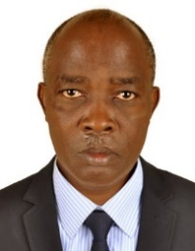
UGANDA NATIONAL EXAMINATION BOARD
PRIMARY LEAVING EXAMINATION
Dr. Bbosa Science
Nurture your dreams
d

digitalteachrs.co.ug

Science 1992
Time allowed: 2hours 15 minutes
Index No:

Candidate’s Name……………………………………………………………………………………..
Candidate’s signature…………………………………………………………………………………..
District Name…………………………………………………………………………………………………
FOR EXAMINERS
USE ONLY
Qn. No | MARKS | EXR’S NO.
1-10
11-20
21-30
31-40
51
52
53
54
55
Total
Read the following instructions carefully
- This paper has two sections A and B. Section A has 50 questions and section B has 5 questions. The paper has 15 pages following altogether.
- Answer all questions. All answers to both sections A and B must be written in the spaces provided.
- All answers must be written using a blue or black ball-point pen or ink. Any work written in pencil other than graphs, pictures and diagrams will not be marked.
- Unnecessary change of work may lead to loss of marks.
- Any handwriting that cannot easily be read may lead to loss to marks.
- Do not fill anything in the boxes indicated:
- “For examiners’. Use only and inside the question paper

©1992 Uganda National Examination board

- Name one source of vitamin B
……………………………………………………………………………………………………………………………………………………..
- Besides carbon monoxide, name one other requirement for photosynthesis to take place in green plants.
……………………………………………………………………………………………………………………………………………………..
- State one way in which bacteria can be useful to man.
……………………………………………………………………………………………………………………………………………………..
- In which way is a housefly dangerous to man.
……………………………………………………………………………………………………………………………………………………..
- How is AIDS be transmitted from mother to unborn baby.
……………………………………………………………………………………………………………………………………………………
- Why is iron important element in our diet?
…………………………………………………………………………………………………………………………………………………….
- How does a flying be produce sound?
……………………………………………………………………………………………………………………………………………………
The below id of a human tooth. Use it to answer questions 8 and 9.
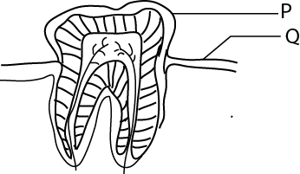
- Name part marked P
……………………………………………………………………………………………………………………………………………………..
- What is the function of structure marked Q
……………………………………………………………………………………………………………………………………………………..
- Bbosa usually brushes his teeth before eating a meal. Why is this not a good practice?
……………………………………………………………………………………………………………………………………………………..
- Which blood cell is responsible for defense of the body?
……………………………………………………………………………………………………………………………………………………..
- How is the chamber of the heart which pumps blood throughout the body adapted to its function?
…………………………………………………………………………………………………………………………………………………….
- Give one possible result of a blocked egg-tube (oviduct) in a woman.
……………………………………………………………………………………………………………………………………………………..
- What is extended family?
……………………………………………………………………………………………………………………………………………………..
- Why do some people usually take alcohol?
……………………………………………………………………………………………………………………………………………………

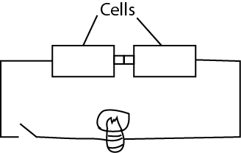
- David connected the circuit as below. Explain why a new bulb did not light when he on a switch?

……………………………………………………………………………………………………………………………………………………………
- A boy bleeding from the nose is made to lie down or sit on a chair with his nose upwards. What should be done next to stop breeding?
……………………………………………………………………………………………………………………………………………………..
- What is the best natural conditions under which cereals like maize can be stored?
…………………………………………………………………………………………………………………………………………………..
- What is the main difference between a simple fracture and compound fracture?
…………………………………………………………………………………………………………………………………………………..
- Why is it important to start weaning a baby after the age of four months?
…………………………………………………………………………………………………………………………………………………..
The diagram blow shows a man using a pole for lifting a piece of stone. Use it to answer questions 21 and 22.
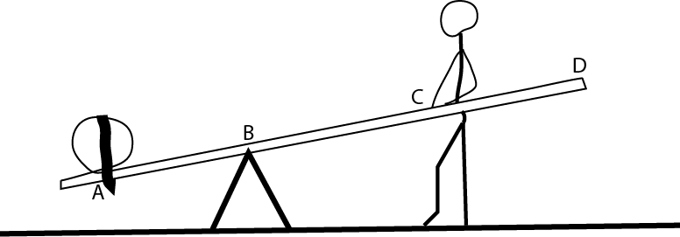
21.on the diagram, show the direction of the effort.
22. what should the man do to lift the load more easily?
……………………………………………………………………………………………………………………………………………………..
23. How does terracing help to prevent soil erosion?
…………………………………………………………………………………………………………………………………………………….
24. How does a tadpole differ from adult frog in the way it takes in oxygen?
……………………………………………………………………………………………………………………………………………………
25. What is pollution?
……………………………………………………………………………………………………………………………………………………..
26. Name one activity that causes air pollution.
…………………………………………………………………………………………………………………………………………………….
27. Question 27 and 28 are on a mushroom.
27. Of what importance is it to man
…………………………………………………………………………………………………………………………………………………….

28. Why does it not obtain food in the same way as a green plant do?
……………………………………………………………………………………………………………………………………………………
29. How is nagana (sleeping sickness) spread?
……………………………………………………………………………………………………………………………………………………..
30. The diagram below shows parts of a plant stem, name the structure marked R.

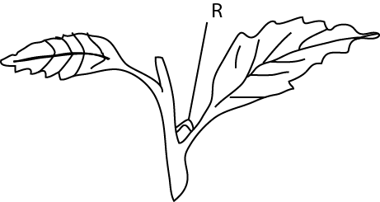
R. ………………………………………………………………………………………………………………..
31. Name a disease which commonly attacks cassava plant in Uganda.
……………………………………………………………………………………………………………………………………………………
32.Why should drugs in a home be kept out of reach of children?
……………………………………………………………………………………………………………………………………………………
33. How is tuberculosis vaccine administered to children?
……………………………………………………………………………………………………………………………………………………
34. What do you understand by primary health care?
…………………………………………………………………………………………………………………………………………………….
35. Where does fertilization take place in a flowering plant?
…………………………………………………………………………………………………………………………………………………….
36. The diagram below shows the beak of a bird. Why do you think a bird with this kind of beak is a meat eater?
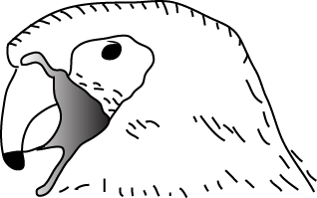
…………………………………………………………………………………………………………………………………………………..
37. State one advantage of the ventilated improved pit latrine (VIP) over ordinary pit latrine.
…………………………………………………………………………………………………………………………………………………..
38. What is the recommended minimum distance between a drinking water and VIP latrine?
………………………………………………………………………………………………………………………………………………….
39. Why is a butterfly regarded as an invertebrate?
………………………………………………………………………………………………………………………………………………….

40. Equal volumes of hot water are poured into two glass container A and B as shown below.
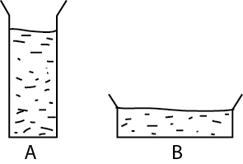

Why would the water in container B cool faster than in container A.
……………………………………………………………………………………………………………………………………………………

SECTION B

41. a) Why do some people smoke?
……………………………………………………………………………………………………………………………………………………..……………………………………………………………………………………………………………………………………………………
(b) What are the possible effect of smoking in a smoke?
…………………………………………………………………………………………………………………………………………………………………………………………………………………………………………………………………………………………………………..
42. the diagram below is a cross section of a maize grain. Study it and answer the questions that follow.

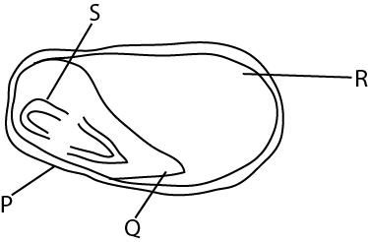
- Name the part marked P and R.
P: ……………………………………………………………………………………………………………………………………
R: ……………………………………………………………………………………………………………………………………
- What will S grow into?
………………………………………………………………………………………………………………………………………..
- What is the function of Q?
…………………………………………………………………………………………………………………………………………

43. (a) Besides retaining soil moisture, what other purpose does mulching serve?
………………………………………………………………………………………………………………………………………………
……………………………………………………………………………………………………………………………………………..
(b) Give one disadvantage of lack of crop rotation.
………………………………………………………………………………………………………………………………………………
……………………………………………………………………………………………………………………………………………..
44. A piece of stone weighs 24g in air. The same stone was placed in a measuring cylinder containing water as shown in the diagram below. The level of water in the measuring cylinder rose from point A to point B.
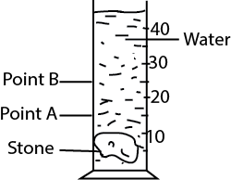
- What is the volume of the stone?
………………………………………………………………………………………………………………………………………………………………………………………………………………………………………………………………………………………………
- calculate the density of the stone.
……………………………………………………………………………………………………………………………………………………………………………………………………………………………………………………………………………………………….
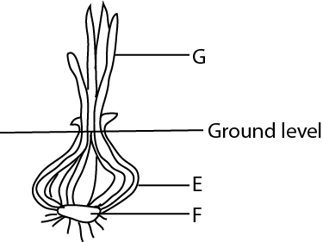
45. the diagram below is of a cross section of an onion. Use it to answer the questions that follow

- Name the parts marked E and F
E: …………………………………………………………………………………………………………………………………….
F: …………………………………………………………………………………………………………………………………….

- What type of root system does it have?
…………………………………………………………………………………………………………………………………………….
- Give the function of the part labelled G?
……………………………………………………………………………………………………………………………………………
46. (a) Give the difference between hinge joint and Ball and socket joint.
…………………………………………………………………………………………………………………………………………………………………………………………………………………………………………………………………………..…………………
(b) Give the function of a tendon.
………………………………………………………………………………………………………………………………………………………………………………………………………………………………………………………………………………………………
(b) Name a disease connected with the muscle and skeleton system.
………………………………………………………………………………………………………………………………………………………………………………………………………………………………………………………………………………………………
47. Briefly explain the rain cycle.
……………………………………………………………………………………………………………………………………………………………………………………………………………………………………………………………………………………………………………………………………………………………………………………………………………………………………………………………………………………………………………………………………………………………………………………………………………...
48. (a) What is the use of a fuse in an electric circuit?
………………………………………………………………………………………………………………………………………………………………………………………………………………………………………………………………………………..………………………
(b) How does a fuse work?
…………………………………………………………………………………………………………………………………………………………………………………………………………………………………………………………………………………………………………
(c) Give two causes of short circuit.
…………………………………………………………………………………………………………………………………………………………………………………………………………………………………………………………………………………………………………
49. (a) What do you understand by family planning?
…………………………………………………………………………………………………………………………………………………………………………………………………………………………………………………………………………………………………………
(b) Give two disadvantages of becoming a parent at an early age.
…………………………………………………………………………………………………………………………………………………………………………………………………………………………………………………………………………………………………………
50. The diagram below is one of the systems of human being
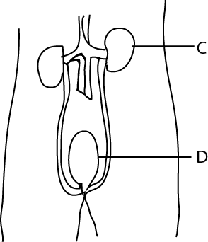

- Name parts labelled:
- A ……………………………………………………………………………………………………………….
- B ………………………………………………………………………………………………………………..
- What is the function of structure C.
…………………………………………………………………………………………………………………………………………………………………………………………………………………………………………………………………………………………………………
51. (a) Of what value is poultry keeping?
…………………………………………………………………………………………………………………………………………………………………………………………………………………………………………………………………………………………………………
(b) What two symptoms would a chicken suffering from new castle show?
…………………………………………………………………………………………………………………………………………………………………………………………………………………………………………………………………………………………………………
52. (a) Give two roles played by young farmers in Uganda
…………………………………………………………………………………………………………………………………………………………………………………………………………………………………………………………………………………………………………
- What is a cooperative society?
…………………………………………………………………………………………………………………………………………………………………………………………………………………………………………………………………………………………………………
(c) Give an advantage of a cooperative society.
…………………………………………………………………………………………………………………………………………………………………………………………………………………………………………………………………………………………………………

53. The diagram below is of a weighing machine which uses liquid.
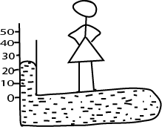

- what is the weight of the girl?
…………………………………………………………………………………………………………………………………………….
- Where will the level of the liquid be when the girl goes off the machine?
………………………………………………………………………………………………………………………………………………
- Explain what happens if a teacher whose weight is 70kg stand on the machine?
…………………………………………………………………………………………………………………………………………….
54. Equal volume of sandy and clay soils were placed into containers as shown in the diagram below. Equal volumes of water were poured into each soil type at the same time. After 10 minutes the volume of water collected are as shown in the diagram.
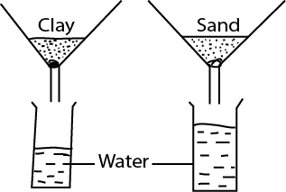

- through which soul did the water drain faster?
……………………………………………………………………………………………………………………………………………
- Give a reason for your answer.
……………………………………………………………………………………………………………………………………………
- Why do the two types of soil allow water to drain at different rates?
…………………………………………………………………………………………………………………………………………………………………………………………………………………………………………………………………………………………
55. (a) State two causes of diarrhea.
……………………………………………………………………………………………………………………………………………………………………………………………………………………………………………………………………………………………..………….
(b) How can diarrhea be prevented?
………………………………………………………………………………………………………………………………………………………………………………………………………………………………………………………………………………………………………….
END

