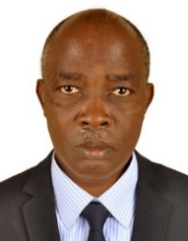UGANDA NATIONAL EXAMINATION BOARD

PRIMARY LEAVING EXAMINATION

Dr. Bbosa Science

Nurture your dreams

d

digitalteachrs.co.ug

**Science 1993**

Time allowed: 2hours 15 minutes

|  |  |  |  |  |  |  |  |  |
| --- | --- | --- | --- | --- | --- | --- | --- | --- |
|  |  |  |  |  |  |  |  |  |

Index No:

Candidate’s Name……………………………………………………………………………………..

Candidate’s signature…………………………………………………………………………………..

District Name…………………………………………………………………………………………………

|  |  |  |
| --- | --- | --- |
| **FOR EXAMINERS**  **USE ONLY** | | |
| **Qn. No** | **MARKS** | **EXR’S NO.** |
| **1-10** |  |  |
| **11-20** |  |  |
| **21-30** |  |  |
| **31-40** |  |  |
| **51** |  |  |
| **52** |  |  |
| **53** |  |  |
| **54** |  |  |
| **55** |  |  |
| **Total** |  |  |

Read the following instructions carefully

1. This paper has two sections **A** and **B.** Section **A** has 50 questions and section **B** has 5 questions. The paper has 15 pages following altogether.
2. Answer all questions. All answers to both sections A and B must be **written** in the spaces provided.
3. All answers must be written using a blue or black ball-point pen or ink. **Any** work written in pencil other than graphs, pictures and diagrams will **not** be marked.
4. Unnecessary change of work may lead to loss of marks.
5. Any handwriting that cannot easily be read may lead to loss to marks.
6. Do not fill anything in the boxes indicated:
7. “For examiners’. Use only and inside the question paper

©1993 Uganda National Examination board

1. Jane put a bottle of soda in a bucket of ice. Two hours later, she found that the soda was frozen and the bottle broken. Why did the bottle break?

**Due to expansion of soda in the bottle**

1. What is the role of brightly colored petals in pollination?

**The attract agent (bird, insects) pollination.**

1. State one reason why loam soil is better than sandy soil for crop growing.

**Contain humus and more nutrients essential for plant growth**

Use the drawing below to answer questions 4 to 8

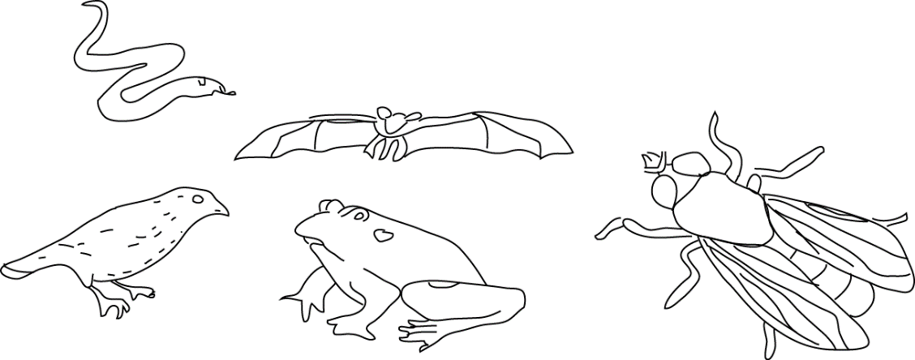

1. Which animal lay eggs?

**Snake, bird, frog and housefly**

1. Which of these animals are cold blooded?

**Snake, frog, house fly**

1. Which of these animals has no back bone?

**Housefly**

1. Which these animals can fly?

**Bat, bird and housefly**

1. Which of these animals is a mammal?

**Bat**

1. Why would an egg from a layer not hatch into a chick after it has incubated for 21 days?

**When the egg is not fertilized**

**When the egg lacks a yolk**

**When the egg was damaged**

1. The chameleon is a slow-moving animal. State one way by which it protects itself.

**It changes color to match with environment not to be seen easily**

1. Why is milk the best food for a baby less than one year old?

**It provides a balanced diet**

**Contains antibodies against diseases**

1. Why should left-over food be properly covered?

**To prevent contamination carried by houseflies**

1. What causes malaria?

**Plasmodium parasite**

The diagram below shows a setup of an experiment and its results. Use it to answer questions 14 and 15

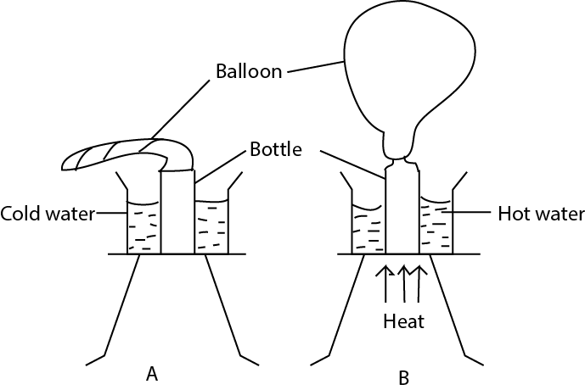

1. Why does a bulb swell out as shown in B?

**Due to expansion of air that fills the bulb**

1. Suggest what you think the experiment is intended to show?

**To show that air expands when heated**

1. Why are people encouraged to drink boiled water?

**It does not contain germs**

1. Why must fruits and vegetables be included in our diet?

**To provide vitamins and roughages**

1. Why does a pregnant mother need food rich in protein?

**To enable the baby in the womb, grow well**

1. Why should finger nails be cut short?

**The minimize the harboring of germs**

1. Why a maize grain is considered a fruit?

**It has two scars**

Use the drawing below to answer questions 21 and 22

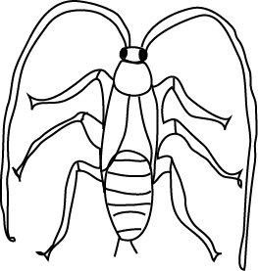

1. What stage in the life cycle of a cockroach is shown in the diagram?

**Nymph**

1. Give a reason answer in question 21.

**The wings are not yet developed**

1. How does a cassava plant obtain its food when its leaves have fallen off?

**From root tuber**

1. Why does a piece of stone placed into water sink?

**A stone is denser than water** `

The diagram below shows a metallic rod made of two different metal X and Y bound together as shown in A. when heated, the rod bends as shown in B. use the diagram to answer questions 25 and 26.

X

Y

Y

X

A

B

1. Which of the metal expands faster, X or Y?

**Y**

1. Give a reason for your answer in 25.

**Y increases more in length than x that it bends outwards.**

1. What is the function of a dry cell?

**Produces current I the circuit**

1. Why does a wet cloth spread on a line inside a house dry?

**Due to evaporation and vapor blown away by wind**

1. What is a compound fracture?

**Is an injury where bone(s) break and come out of the body.**

1. What First Aid should be given to a person with a compound fracture on the arm?

**Tie a splint around the broken bone and hold the arm in one position by a sling.**

1. Why must one avoid being near a person who is smoking?

**To avoid danger like lung cancer due to passive smoking**

1. Of what use is a ventilator of a house?

**It allows fresh air through the house**

1. What do you understand by |drug dependence”

**It where a person is addicted to a drug that he cannot do without it.**

1. What vector (animal) carries bubonic plaque germs?

**Rat**

1. Why should a pit latrine be smocked from time to time?

**To remove bad smell and kill flies that spread germs**

1. Bbosa shares his house with goats. State the disadvantage of this practice.

**The goat may spread disease to the family**

**The goat competes for oxygen with the family**

**Let out bad air**

1. Some charcoal is burnt in a container as shown in the diagram below. The container and its contents were weighed before and after. There was no change in the weight. Why was there no change?

Heat

Charcoal

Test tube

Air

Air- tight cover cover

1. State one cause of fainting.

**Lack of enough oxygen in blood going to the brain**

1. A ray of light meets the surface of the mirror as shown in the diagram below. Draw a reflected ray. (Use of a compass not necessary)

Mirror

Ray of light

Reflected ray of light

500

1. What is the importance of weeding in growing crops?

**Prevents competition for water, nutrients and light**

SECTION B

1. The diagram below is of an Irish potato. Use it to answer questions (a) to (d)
2. What part of the Irish potato is shown in the diagram?

**Stem tuber**

1. Give a reason for your answer in (a)

**Contain bud**

1. What is the main food value does the Irish potato have?

**Carbohydrates**

1. How does the method of propagation of Irish potato different from that of sweet potato?

**Irish potato is propagated by stem tuber whereas sweet potatoes by stem cutting**

1. The table below gives a list of diseases against which children should be immunized and the age in months in which the first dose of vaccine should be given?

|  |  |
| --- | --- |
| Disease | **Age in months** |
| Tuberculosis | At birth |
| Tetanus | 1 ½ |
| **Diphtheria, polio** | 1 ½ |
| **Measles** | 9 |

(b) why is the importance of health card?

**Help monitor child’s growth**

**Show which disease (s) were the child immunized against**

**Shown the date of birth and sex**

1. (a) Give two possible source of worm infection?

**Eating unready meat**

**Walking bare foot**

**Drinking contaminated water**

**Living in dirty environment**

(b) state two signs of worm infection

**Pains in the stomach**

**Having an itchy body**

**Feeling hungry after eating**

**Swollen body (stomach)**

1. Uganda electricity Board generates most of it electricity at Jinja.
2. State the source of electricity energy

**Running water**

1. How does the electricity generated at Jinja get to a consumer in Kampala?

**Transmitted through wires**

1. Give two uses of electricity to a family?

**Providing light at home**

**Cooking**

**Enable the use of electric appliance e.g. Radio, T.V set**

1. Below is a drawing of a pin-hole camera with an image of an object formed on the screen. The object is located along line PQ.

P

Q

Screen

Object

1. Draw lines to show how the image is formed.
2. Draw the object
3. Compare the image and the object.

**The image is inverted**

**Both the image and the object are real**

1. Bbosa pulls a load of 50kg over a set of metal rollers. Peter pulls another load of the same weight along the ground (see diagram below)

Load

Load

Roller

John

Peter

1. Explain why one of the two (people) uses less force.

**John uses less force because the rollers minimize friction at the surface**

1. What is the advantage of a driver pouring sand on a slippery road.

To increase friction to facilitate movement.

1. Explain your answer in (b) above?

**Sand makes slippery road rough which increases friction**

1. The AIDS virus does not kill a victim.
2. What leads to a person infected with AIDS virus to death?

**AIDS virus destructs the white blood cells making it easy for the germs to infect the victim and kill him/her**.

1. Why should one not be afraid sitting in the same classroom with a person infected with the AIDS virus?

**AIDS is only transmitted can only be transmitted through exchange of body fluid only**.

1. What is the commonest method through which the AIDs virus is spread?

**Unprotected sex with infected person**

1. (a) How does each of the following helps to maintain soil fertility?
2. Crop rotation

**Prevents soil exhaustion of certain nutrients.**

1. Mulching

**Retains moisture in the soil.**

**Mulch decays to humus.**

(b) give two other ways of maintaining soil fertility.

**Mixed cropping with legumes**

**Addition of fertilizers to the soil**

1. A child suddenly removed the cover of a saucepan full of boiling water. One arm of the child was burnt with steam.
2. What kind of burn did the child get?

**Scald**

1. What First AID would you give to the child

**Pour cold water on the scald**

1. Give the possible ways by which such accidents could be avoided?

**Keep small children away from hot objects**

**Construct fire guard around fire places.**

**Children should be taught dangers of fire and hot objects.**

1. (a) Give two types of cattle

**Zebu**

**boran**

(b) Why do cattle keepers encouraged to practice paddock system of grazing?

**- To separate infected cattle from noninfected one.**

**- to allow growth of grass and to avoid over grazing**

**- for easy monitoring.**

1. Below is a diagram showing an eye defect.



1. Name the eye defect shown in the diagram above.

**Short sightedness**

1. Give reasons for your answer in (a) above

**Image formed in front of the retina**

1. How can this eye defect for your answer in (a) above corrected?

**Use a concave lens**

1. (a) State two functions of mammalian teeth?

**Incisors cut food**

**Canine tear food.**

**Molar grind food.**

(b) An elderly man has lost all his molar teeth. What feeding problems would be experience?

**He would not be able to grind food easily**

**He would be able to swallow easily**

1. (a) Give two reasons why burning and rusting are considered similar reactions.

**Both require oxygen to occur**

**Both are chemical change**

(b) A farmer noticed that whenever he leaves his hoe outside the whole day, on a clear day, it does not rust; but whenever he leaves the same hoe at night, it rusts. Why is this the case?

In the night there is moisture and oxygen necessary for rusting whereas during day there in not enough moisture

1. The diagram below is of a fish. Study it and answer the questions that follow.

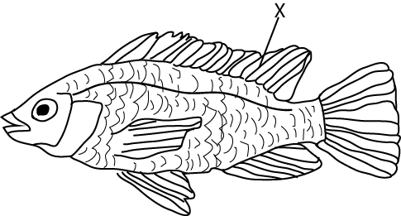

Y

1. Name the part labelled X

**Dorsal fin**

1. Mark with Y the position of the gills
2. How does the fish take in oxygen?

**Swallow water with oxygen, this passes over the gills where gaseous exchange takes place**

1. (a) What is an essential drug

**These are drugs that must be readily available, cheap and effective drugs.**

(b) Give an example of an essential drug.

Panadol, spirin, coetum

(c) Why are prescriptions important in the treatment of sickness?

**To give proper treatment**

**To prevent overdose or underdose**