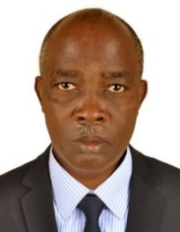UGANDA NATIONAL EXAMINATION BOARD

PRIMARY LEAVING EXAMINATION

Dr. Bbosa Science

Nurture your dreams

d

digitalteachrs.co.ug

**Science 1995**

Time allowed: 2hours 15 minutes

|  |  |  |  |  |  |  |  |  |
| --- | --- | --- | --- | --- | --- | --- | --- | --- |
|  |  |  |  |  |  |  |  |  |

Index No:

Candidate’s Name……………………………………………………………………………………..

Candidate’s signature…………………………………………………………………………………..

District Name…………………………………………………………………………………………………

|  |  |  |
| --- | --- | --- |
| **FOR EXAMINERS**  **USE ONLY** | | |
| **Qn. No** | **MARKS** | **EXR’S NO.** |
| **1-10** |  |  |
| **11-20** |  |  |
| **21-30** |  |  |
| **31-40** |  |  |
| **51** |  |  |
| **52** |  |  |
| **53** |  |  |
| **54** |  |  |
| **55** |  |  |
| **Total** |  |  |

Read the following instructions carefully

1. This paper has two sections **A** and **B.** Section **A** has 50 questions and section **B** has 5 questions. The paper has 15 pages following altogether.
2. Answer all questions. All answers to both sections A and B must be **written** in the spaces provided.
3. All answers must be written using a blue or black ball-point pen or ink. **Any** work written in pencil other than graphs, pictures and diagrams will **not** be marked.
4. Unnecessary change of work may lead to loss of marks.
5. Any handwriting that cannot easily be read may lead to loss to marks.
6. Do not fill anything in the boxes indicated:
7. “For examiners’. Use only and inside the question paper

©1995 Uganda National Examination board

SECTION A

1. Bbosa caught fish to feed for a month. Suggest one way by which Bbosa’s family can safely keep the fish to last one month.

**Refrigeration**

**Salting**

**Smoking**

**Sun**

1. Why are cockroaches classified as invertebrates?

**They lack a back bone**

The diagram below is of a clinical thermometer. Use it to answer questions 3 to 6.

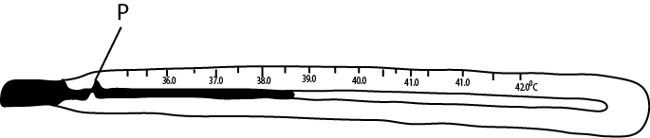

1. What liquid is used in thermometer?

**Mercury**

1. What is the main function of the part labelled P?

**To prevent backflow of mercury when measuring and reading temperature**.

1. The temperature of a person was taken and the liquid rose to the level as shown in the diagram above. What was the person’s temperature?

**38.50C**

1. Why would you support that person in question 5 above had malaria?

**The temperature of the person is above the normal temperature of 370C.**

1. Mention one way by which the supply of clean water in rural area is being improved.

**Building boreholes**

**Constructing spring wells away from the pit latrine**

**Cleaning spring wells**

1. State one way in which bacteria is useful to man.

**Convert rubbish to humus**

**Fix nitrogen to the soil**

1. Why are tape worms called parasites?

**They feed on humans as well as causing harm to him**

1. Why does Uganda Electricity Board worker wear rubber gloves when working on wires carrying electricity?

**To prevent electric shock**

1. Name one disease which attacks both poultry and rabbits.

**Coccidiosis**

1. How can a person become infected with tetanus?

**Through rotting wounds**

**Through cuts**

1. State one way in which evaporation is useful to man.

* **Helps in rain formation**
* **Evaporation of sweat cools the body**
* **Evaporation dries clothes**

1. What is the difference between the organism that cause the AIDs disease and that of gonorrhea?

**AIDS is caused by a virus while gonorrhea is caused by a bacteria**

Below is a table with column for vitamins, source of vitamins and the related deficiency diseases. Fill in the table to answer questions 15 to 17.

|  |  |  |  |
| --- | --- | --- | --- |
|  | Vitamin | Source | Deficiency disease |
|  | **Vitamin D** | Milk | Rickets |
|  | A | Pawpaw | **Night blindness** |
|  | B1 | **Groundnuts**  **Yeast**  **Beans**  **Whole grain of cereal** | Beriberi |

1. State one reason why air in the soil is important.

**Used by germinating seed**

**Used by plant roots for respiration**

**Used for respiration by microorganisms**

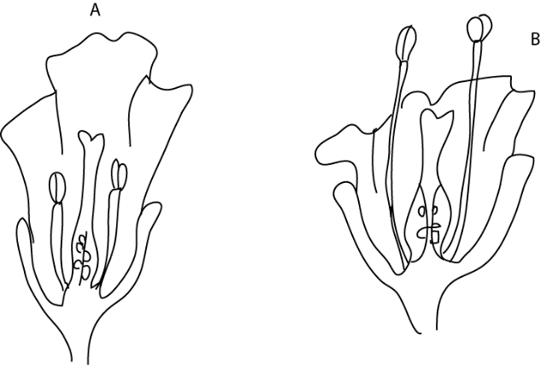The diagram below are of flowers A and B. Use them to answer questions 19 and 21

1. Which of the two flowers is likely to be insects pollinated?

**Flower A**

1. Give one reason for your answer to question 19.

**The stigma is higher than the anthers**

1. How is the other flower likely to be pollinated?

**By wind because anthers are shorter than the stigma that the pollen grain can easily fall on the stigma**

1. Which First Aid would you give to a person who has a burn by fire?

**Pour cold water to burnt area to reduce the effect of burn**

1. The diagram below is of a machine used for picking charcoal. Indicate on it, with letter F, the position of a fulcrum.

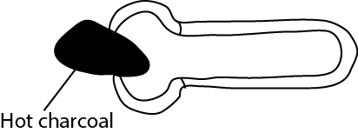

Hot Charcoal

F

1. Why should a woman eat more food when she is pregnant than when she is not?

**To provide extra nutrient for the baby**

1. Complete the rays of light in the diagram below to show a condition of short-sightedness.

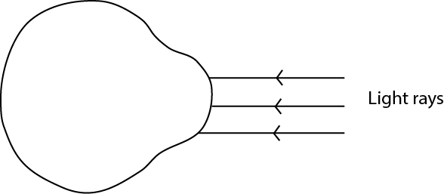

1. Name one function of the small intestine on an animal.

**To absorb digested food**

1. State one reason for juvenile delinquency (wrong behavior by children).

* **Peer pressure**
* **Drug abuse**
* **Overstrictness by parents/teachers**

1. Give the main reason why crop rotation maintain fertility.

* **When legumes are included they fix nitrogen in the soil.**
* **Crop rotation prevents exhaustion of a single nutrient.**

1. In the diagram below, A, B, C, d. are cards with small holes as shown below. Student at E is trying to see the light at A through the holes.

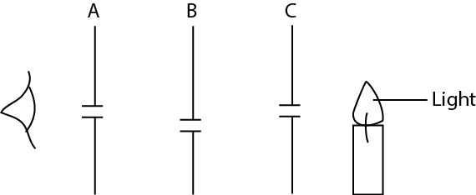

Why can’t the light be seen at E?

Because the holes in the cardboards are not in straight line.

1. Why is it more difficult to breath in a room full of smoke than in open compound?

**Smoke suffocates**

1. What is the use of a nerve to a person?

**Transport impulses to and from the central nervous system**

The diagram below shows light falling on a plane mirror. PQ. Use it to answer question 32 and

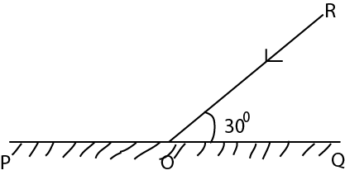

1. Complete the drawing accurately, to see the reflected ray.
2. What is the value of the angle of reflection?

**Angle of reflection = angle of incidence = 90-30 = 60**

1. State one way by which body lice can be avoided?

**By keeping clothes clean**

**By ironing clothes**

**By bathing regularly**

1. Where does a ground nut store most of its food?

**In the seeds**

1. Why are mushrooms carry out photosynthesis?

**They lack chlorophyll**

1. State the main reason for planting seeds in the soil.

**Because soil contain water, air, nutrients for the plants.**

1. Bbosa is suffering from severe malaria. Why would you not advise him to take medicine than that prescribed by a medical doctor?

**It may lead to overdose**

**He may take a wrong drug**

1. David dropped some oil on a piece of paper. Why does he fail to write with a ball pen on the sport where oil has dropped?

**Oil removes friction from the paper**

1. David is asked to find the volume of a piece of stone, the volume of which is about 300cm3. He was provided with 20cm3 of water, a graduated cylinder and an over flow can. He found that this experiment would not work. Suggest one way how it can be made to work.

He should increase the volume of water above 300cm3

**SECTION B**

1. (a) state one type of cattle

**Dairy cattle e.g., Friesian, Jessy**

**Beef cattle: Baron, angus, Galloway**

**Dual purpose cattle**

(b) Name two breed of cattle found in Uganda

**Local breed e.g. Ankole, Boran, Zebu**

**Exotic breed e.g. Friesian, jersey**

**Cross breed (hybrid)**

(c) give one advantage of cross-breeding with exotic bull.

**To obtain hybrid with high milk production and cattle that grow fast.**

1. Betty’s home is near a pond.
2. state any two diseases members of Betty’s family are likely to suffer from.

**Malaria**

**Typhoid**

**Yellow fever**

**bilharzia**

1. Suggest one thing that Betty can do to avoid one of the disease mentioned.

**Sleeping in mosquito net**

**Pouring oil on the pond to reduce mosquito breeding**

**Draining the pond to remove mosquito breed place**

**To add small fish in the pond to eat mosquito larvae.**

1. How is scabies spread?

**By body contact with infected person.**

**By sharing clothes with infected person**

1. (a) What do you understand by adolescence?

**Is a period between childhood and adulthood**

(b) Name two secondary sex characteristic of adolescence.

Growth of pubic hair

Development of breasts in girls

Development of broad chest in boys

1. Give one disadvantage of pregnancy in adolescence

* Lead to school drop out
* Giving birth may be a problem leading to death of mother and a child
* Attempted abortion may lead to death
* Failure to support he baby

1. 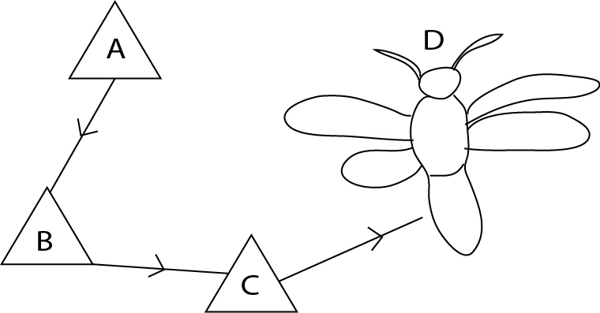The diagram below shows the life cycle of a butterfly. Use it to answer the questions which follow.
2. Name the stages A and B.

**A: eggs**

**B: larva**

1. At what stage is a butterfly a pest?

**Stage B**

1. State one reason why a butterfly is classified as an insect.

**Butterfly has three main body parts**

**Has three pairs of legs.**

1. (a) State any two ways of acquiring immunity.

Artificial immunity through vaccination

Natural immunity through colostrum

Suffering from disease and recover from it

(b) Apart from the six killer diseases, state any one other disease where one can acquire immunity.

**Hepatitis**

**Meningitis**

**Yellow fever**

**Typhoid**

1. Why is it not possible to acquire immunity against AIDs disease?

* Because AIDS virus attacks white blood cells which weaken immunity of a person
* The AIDS virus has very many forms that it is difficult to develop immunity to very many forms

1. Use the diagram X and Y below to answer the questions that follow.

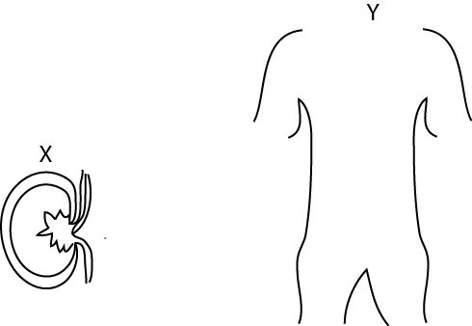

1. Name the organ shown in diagram X.

**Kidney**

1. What is the function of the organ shown in diagram X?

**To remove waste metabolic products from the blood**

**To regulate amount of water in the body**

**To regulate body pH**

1. 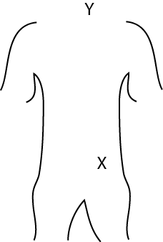Mark on the drawing Y the position of the organ shown in drawing X.
2. Name another organ in a mammal that carries out a similar function as the organ shown in the drawing X.

**lungs**

**skin**

1. (a) in the space below, draw an example of:
2. A simple leaf
3. A compound leaf
4. State any one use of a leaf to a plant other than photosynthesis.

**Food storage**

**Water storage**

**Vegetative reproduction**

**Gaseous exchange**

**Transpiration**

1. Apart from being eaten as food, name one other use of leaves to man.

**Herbal medicine**

1. Use the list of plants given below to answer the questions that follow

Beans, mosses, conifers, mushrooms

1. Which two plants would you group together as members of one family

**Beans and conifer are seed beading plant**

**Mosses and conifer are non-flowering plants**

1. Give a reason for your answer in (a) above
2. Which one of the above plants reproduces by means of flowers?

**Bean**

1. In what kind of environment would you find mosses?

**Wet and damp environment**

1. 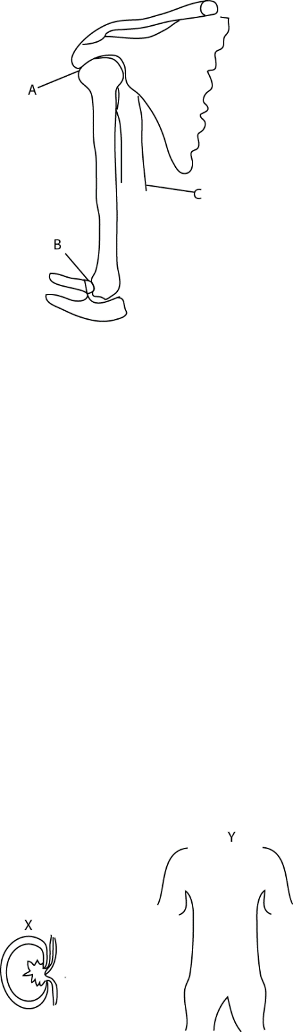The diagram below is of a part of a human arm, use it to answer the questions which follow
2. Name the joint A

Ball and socket joint

1. What kind of movementt does the joint A allow?

Allows movement in one plane

1. 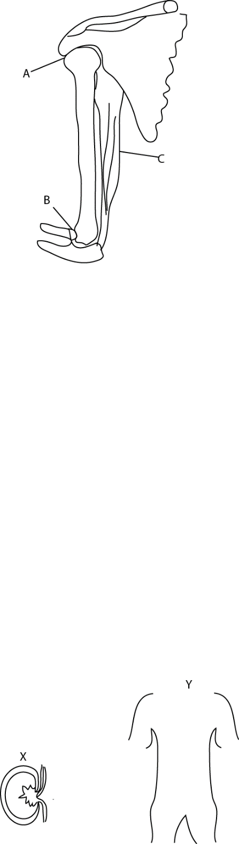Complete the drawing of muscles C to show where its lower end is attached.
2. If the arm is in the position shown, name the muscle which must be contracted.

**Biceps**

1. Two containers A and B containing some water as in the diagram below, were heated.

Heat

A

B

saucepan

saucepan

1. In which container did water boil first?

A

1. Explain your answer in (a) above.

**Has less water that require less heat to boil**

1. Matata came back from school and found a piece of left over boiled potato which was not covered. Because he was very hungry, he began to eat it at once.
2. State two good heathy practice which Matata did not follow.

* **Did not wash his hands first**
* **He did not warm the food before eating it**

1. Name a disease Matata could suffer from

* **Diarrhea**
* **Cholera**
* **dysentery**

1. Give a reason for your answer in (b) above?

**Housefly could have left germs because it was not covered.**

1. A married couple has 10 children. The oldest is 15 years while the youngest is 3months old.
2. State two problems this family is likely to face.

**Lack of enough food**

**Lack of proper medication**

**Congestion in a house**

1. Mention one health problem the mother may face

**Mother’s uterus may be destroyed**

**Premature birth**

**Mothers death**

**Maternal anemia**

1. State one suitable advice you would give to this family.

**Should join family planning**

1. (a) State one way in which you can distinguish between a poisonous snake and a nonpoisonous one

**- poisonous snakes has fangs while nonpoisonous snake does not have fangs**

(b) Give an example of a poisonous snake.

**Cobra**

**Puff adder**

**Black mamba**

(c) What First Aid is given to a person bitten by a poisonous snake?

**Cut the injured part to allow breeding**

**Put a black stone to absorb poison**

**Tie the cloth between the heart and the bitten part.**

1. (a) How does heat travel through:
2. Water?

By convection current

1. Vacuum?

By radiation

1. Explain how the sun heats the air around us.

**By convection; the sun rays heat the air near the ground which becomes less dense compared to the upper layer of air and thus the warm air rises and it is replaced by the cool air.**

1. The figure below is accurately drawn. What is its volume?

Length = 4.6cm

Width = 3.4cm

Height = 2.8cm

Volume = L x W x H

= 4.6 x 3.4 x 2.8

= 43.792 cm3

thanks