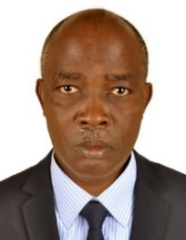UGANDA NATIONAL EXAMINATION BOARD

PRIMARY LEAVING EXAMINATION

Dr. Bbosa Science

Nurture your dreams

d

digitalteachrs.co.ug

**Science 1996**

Time allowed: 2hours 15 minutes

|  |  |  |  |  |  |  |  |  |
| --- | --- | --- | --- | --- | --- | --- | --- | --- |
|  |  |  |  |  |  |  |  |  |

Index No:

Candidate’s Name……………………………………………………………………………………..

Candidate’s signature…………………………………………………………………………………..

District Name…………………………………………………………………………………………………

|  |  |  |
| --- | --- | --- |
| **FOR EXAMINERS**  **USE ONLY** | | |
| **Qn. No** | **MARKS** | **EXR’S NO.** |
| **1-10** |  |  |
| **11-20** |  |  |
| **21-30** |  |  |
| **31-40** |  |  |
| **51** |  |  |
| **52** |  |  |
| **53** |  |  |
| **54** |  |  |
| **55** |  |  |
| **Total** |  |  |

Read the following instructions carefully

1. This paper has two sections **A** and **B.** Section **A** has 50 questions and section **B** has 5 questions. The paper has 15 pages following altogether.
2. Answer all questions. All answers to both sections A and B must be **written** in the spaces provided.
3. All answers must be written using a blue or black ball-point pen or ink. **Any** work written in pencil other than graphs, pictures and diagrams will **not** be marked.
4. Unnecessary change of work may lead to loss of marks.
5. Any handwriting that cannot easily be read may lead to loss to marks.
6. Do not fill anything in the boxes indicated:
7. “For examiners’. Use only and inside the question paper

©1996 Uganda National Examination board

1. Common salt give flavor to our food. State on more use of slat in our diet.

**Preserve diet**

**For water balance in the body**

1. In which way is burning similar to rusting?

**They both use oxygen**

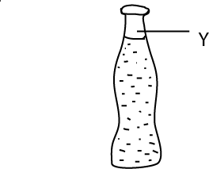The diagram below is of a sealed soda bottle. Use it to answer questions 3 and 4.

1. Why was the space labelled Y left in the bottle?

**To allow for expansion of the liquid and space for carbon dioxide**

1. Name the gas that bubbles out when the soda is opened.

**Carbon dioxide**

1. Apart from light, carbon dioxide and water, what else does a leaf need to accumulate food?

**chlorophyll**

1. Why is a person who is suffering from diarrhea given oral rehydration salts?

**To replace lost water and salt**

1. The driver started at 8.00am from Kampala. He reached Masaka which is 120km at 10.30am. what was his average speed?

**Time taken 10.30 – 8.00 = 2 ½ hours**

$speed= \frac{Distance}{time}$**= $\frac{120}{\frac{5}{2}}= \frac{120 x 2}{5}=48km{hr}^{-1}$**

1. Peter’s maize did not do well because he left weeds in the maize garden. What are weed?

**Weeds are unwanted plants in a garden that compete for nutrients with our crops**

1. State one method of avoiding tooth decay.

**Regular brushing of teeth after every meals.**

1. What is the use of an anemometer in a weather station?

**Anemometer measures wind speed**

1. What First Aid would you give to a person who is bleeding through the nose?

Make a person lean forward and pitch the nose to stop bleeding

Bbosa has the foods named below to feed his family.

Use the list to answer questions 12 to 15

**Mangoes**

**Potatoes**

**Beans**

**Rice**

**Green dodo**

1. Mrs. Bbosa has anemia, which food from the list would you advise her to eat?

**Green dodo and beans**

1. Give reason for your answer in question 12.

**They are both source of iron for formation of hemoglobin.**

1. Which food from the list would you recommend for Bbosa’s child suffering from Kwashiorkor to eat?

**beans**

1. Give a reason for your answer in question 14.

**Source of proteins**

1. What type of a family has the following, husband, wife, daughter and nephew?

**Extended family because nephew is not a biological child**

1. State some one major reason why breast milk is considered the best food for a bay?

**Contains all food nutrients needed by the child**

1. Why is mercury is used in a thermometer?

**Mercury expands uniformly**

**Mercury does not wet glass**

**Mercury does not wet glass**

**It does not evaporate in glass**

1. Why is a child immunized against measles at age of 9 months but not soon after birth?

**At birth the child is protected by antibodies from the mother**

**At birth the vaccine is too strong for the baby**.

1. State one way of reducing friction.

**By oiling**

**By greasing**

**By use of roller**

**By use of ball bearing**

1. Why is it advisable to cover your mouth with handkerchief when sneezing?

**To prevent transmission of germs in the air**

1. What is the importance of red blood cells in human body?

**Transport oxygen in blood**

1. Give one reason why loam soil is good for planting crops?

**It contains humus and most nutrients needed for plant growth.**

1. Scurvy is cause by lack of a vitamin. Name the vitamin.

**Vitamin C**

1. Name the main food you would eat to prevent scurvy?

**Fruits like oranges, lemon**

1. In the space below, draw a monocotyledonous plant.
2. What part of the ear is likely to be damaged if you clean your ear with a sharp object?

**Eardrum**

1. Calculate the mass of an object whose volume is 15cm3 and density is 30g/cm3.

**Mass = density x volume**

**= 30 x 15**

**= 450g**

1. State one reason why David should keep record on his farm.

**To know the number of each type on his farm**

**To know his expenditure**

**To** **know the amount of food required by his animal**

1. Bbosa lost all the molars. What problems is he likely to have while eating?

**Bbosa is likely to have a problem of chewing food**

1. State one way in which a family can avoid the spread of tuberculosis.

**Avoid smoking**

**Not sharing cups and plates with infected person**

**Take treatment in the right way**

1. In the diagram below indicate using an arrow the direction of the flow of electricity.



1. State one reason why water is important in our diet.

**Soften food**

**Regulate body temperature**

**To replace water lost in sweating and urination**

1. What is the best way of protecting cattle against foot and mouth disease?

**Vaccination**

**Keeping infected animal from none infected animals**

**Conducting quarantine**.

1. State one characteristic of an image formed by a pin hole camera.

**It is upside down or inverted**

**It is real**

1. State a mammal which lives in both land and water in Uganda.

**Hippopotamus**

1. What is weaning a child?

**Is a process of making a baby get used to other foods while breast feeding**

Use the picture of an animal below to answer question 38 and 39



1. What does the animal shown in the picture above feed on?

**Flesh**

1. Why do you think the animal above is important in our community?

**Get ride off dead bodies from the environment**

1. Give one example of underground stem.

**Rhizome, corm**,

SECTION B

1. Bbosa stepped on a burning charcoal by accident. He immediately removed the foot.
2. Wat name is given to his immediate reaction?

**Reflex action**

1. Which part of the body controls this type of reaction?

**Spinal chord**

1. Name the muscles which helped Bbosa to remove the foot immediately.

**biceps**

1. What first Aid would you give Bbosa?

**Step in clean cold water**

1. The diagram below represents an instrument used in science.

Use it to answer the questions that follow:

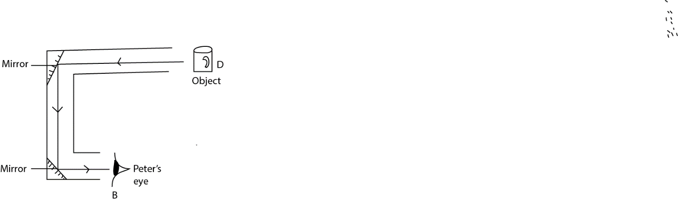

1. How is peter at position B able to see the object at D?

**By reflection through the mirrors**

1. What type of mirrors are used in this instrument?

**Plane mirrors**

1. What is the name of this instrument?

**Periscope**

1. Give the situation where this instrument is used?

**Those objects at the surface of water by people in submarine**

1. State one reason why a frog is able to live both on land and water comfortably.

**In water it breathes through the skin, no land through the lungs**

(b) to which group of animals does it belong?

**Amphibians**

(c) What helps a frog to swim easily?

**It has webbed feet**

1. How does it protect its eggs?

**It spreads spawn jelly around the eggs**

1. The pie chart shows the proportion of air. They are labelled A, B, C, D. use it to answer the questions that follow.

D

A

B

C

1. Which letter in the pie chart represents the gas which supports both breathing and burning?

**C**

1. What is the use of the gas labelled A?

**It is used to put off fire from burning objects**

Name the gas labelled

1. D: **nitrogen**
2. A: **carbon dioxide**
3. The diagram below shows how rain is formed. Use it to answer the questions that follow.

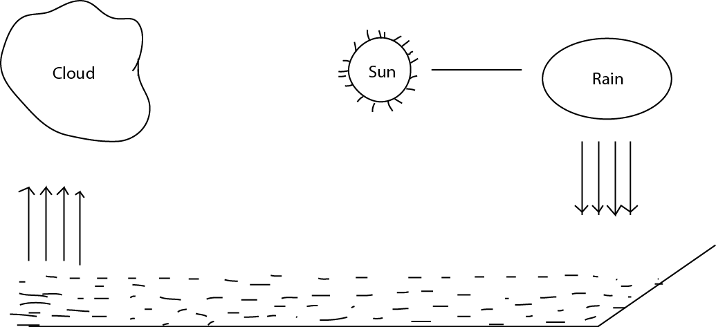

B

1. What causes the water vapour to rise from the river as shown in the diagram?

**Heat from the sun**

1. What happen to water vapour at B?

**It condenses to form cloud**

1. Name the force that helps rain to fall.

**Gravitation force**

1. What name is given to the process shown in the diagram?

**Water cycle**

1. (a) How does a banana plant multiply?

**By suckers**

(b) what insect pest attacks banana

**Banana weevil**

1. In which part of the plant would you find this pest?

**Stem**

(d state the method you would use to control the insect pest.

**Use insecticide to kill the pest.**

**By destroying infected plant**

1. Lightening is dangerous to man
2. State two precautions you would take to avoid being struct by lightening.

**Putting lightening conductors on buildings**

**Not standing under the tree during rain**

1. Which forms of energy does lightening have?

**Light energy**

**Sound energy**

**Heat energy**

1. Bbosa wants to start a livestock farm. State any four basic requirement he must consider for his farm to succeed.

**Capital**

**Availability of**

**Good breed animals**

**Nearness to market**

**Availability of security**

1. Food was given to very hungry children and they ate it very fast without chewing.
2. State any two problems that are likely to affect their digestion system.

**Indigestion**

**Vomiting**

**constipation**

1. State two uses of saliva in in the digestive system.

**Softens food**

**Lubricates food for swallowing**

**Contains amylase enzyme that digests starch**

1. (a) Give two reasons why First Aid is given to a patient.

**To prevent further injury**

**To minimize pain**

**To promote recovery**

**To reduce bleeding**

(b) State two reasons why proper medical prescription is necessary before taking any medicine.

1. The table below shows crops pests and the crop they destroy. Complete the table by filling in the blank spaces.

|  |  |
| --- | --- |
| Pest | Crop |
| 1. **Rabbit or caterpillar** | Potato leaves |
| 1. Birds | **Millet, sorghum, rice, wheat** |
| 1. **Caterpillars, false coding months** | Orange leaves |
| 1. Aphids | **Beans, fruit** |

1. (a) Name any two immunizable diseases caused by bacteria.

**Tuberculosis**

**Polio**

**Tetanus**

**Whooping cough**

1. State two uses of Health cards

**To know the weight of the baby**

**To know the sex**

**To know the date of birth**

**To know which vaccines already given**

**To monitor child’s growth**

1. The diagram below shows a boy collecting water from a water pump. Use it to answer the questions that follow.

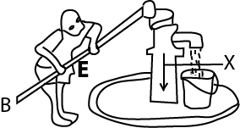

1. Mark on the diagram with letter E the position of the effort.
2. What does the part marked X represent?

**Atmospheric pressure**

1. What change would the boy experience if he moved the hands to position B?

**He would uses less effort to pump water**

1. If the effort is 20, and the load is 80, what is the mechanical advantage of the pump?

**Mechanical advantage = $\frac{load}{effort}=\frac{80}{20}=4$**

1. The diagram below shows the root of a plant. Use it to answer the questions that follow.

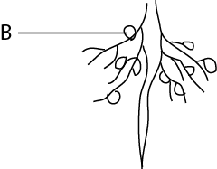

1. Name the part labelled B.

**Root nodules**

1. What group of plants have such roots

**Leguminous plants**

1. What does part labelled B contain?

**bacteria**

1. What is the function of what you named in (c) above?

**Fix nitrogen to the soil**

1. Describe an experiment to show that water can exist in all three states of matter.

**When ice is heated it turns into liquid (water) and on further heating it turns into vapor (steam)**