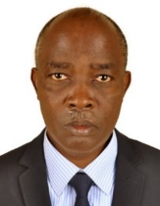
UGANDA NATIONAL EXAMINATION BOARD
PRIMARY LEAVING EXAMINATION
Dr. Bbosa Science
Nurture your dreams
d

digitalteachrs.co.ug
2004
MATHEMATICS
Time allowed: 2hours 30 minutes
Index No:

Candidate’s Name……………………………………………………………………………………..
Candidate’s signature…………………………………………………………………………………..
District Name…………………………………………………………………………………………………
FOR EXAMINERS
USE ONLY
Qn. No | MARKS | EXR’S NO.
1-5
6-10
11-15
16-20
21-22
23-24
25-26
27-28
29-30
31-32
TOTAL
Read the following instructions carefully

Read the following instructions carefully
- This paper has two sections A and B.
- All the working. For both section A and B must be shown in the spaces provided
- All working must be done using a blue or black ball
Point pen or fountain pen Diagram should be drawn in pencil
- No calculators are allowed in the examination room.
- Unnecessary change of work may lead to loss of marks
- Any hand writing that cannot easily be read may lead to loss of marks
- Do not fill anything in the boxes indicated:
“For examiners use only”. And those inside the question paper

©2012 Uganda National Examination board

Turn over
SECTION A
1. Air a mixture of gases. Which of the of gases forms the greatest percentage of air in the atmosphere?
Sandy soil
2. Give any one characteristic which is common to all vertebrates
They have endo skeleton
They have a back bone
3. What first aid would you give a person who is suffering from diarrhea?
Give oral rehydration salt solution to replace lost water
Give fruits
4. In which process can water be changed into water vapour?
Evaporation
5. Give any one way in which ringworm is spread.
By contact with infected person
Sharing clothes with infected person
6. Give any one reason why you would choose to use solar energy stead of wood fuel as a source of energy.
Solar energy does degrade the environment
Solar energy is not exhausted
7. Give any one reason why people should cut their fingernails
Longer nails keep germs
8. Apart from having bright colours, state any other characteristic of insect –pollinated flowers.
Have strong scent
Stigma is longer than the anthers
9. Give any one reason why the burning of wood is a chemical change.
It is irreversible
A new substance (ash) is formed

10 How is the air we breathe in different from the air we breathe out?
The air we breathe in contain more oxygen and less carbon dioxide than the air we breathe out.
11. Give any one characteristic that can help you distinguish between a hen and a cock.
Hens possess small crowns while big crown
Cock possess big comb whereas hen do not
12. Mary suspended three magnets on strings near each other and observed that some ends came close but other ends moved away from each other. Why did this happen?
The ends that came together had unlike poles while those that moved away had like poles.
13. Apart from hearing, give any one other function of the human ear.
To balancing pressure in the head
For posture
14. How do animals benefit from photosynthesis?
They obtain oxygen for breathing in
They obtain food
15. Give any one way in which a P7 pupils can help in the control of polio in a community.
Sensitize people to vaccinate their children
16. Give any one way in which a Child Card is important to a school Health Committee.
It shows whether a child was immunized
It gives a healthy record
17. Suggest any one reason why people drink alcohol.
- to pass time
- to forget their problem
- to get sleep
- to make friends
- to relax

18. Peter uses a wheel barrow to carry potatoes from his garden to the market. What is the advantage of using such a machine?
Less effort is required
The diagram below shows parallel rays striking a comes lens. study it and answer question 19 and 20.
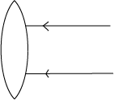

19. Complete the diagram to show the path of the rays after passing through the lens
20. What eyes defect does this type of lens correct?
Long sightness (hypermetropia)
21. Give the part of an insect that has the same function as the gills of a fish.
Spiracles
22. Apart from the animal kingdom, which other of organisms makes up living things?
Plants, fungi, unicellular organism
23. How can a poultry farmer prevent hens from eating their own eggs?
By debeaking
Giving them food on time
Providing dark laying places
Providing enough space
24. Which property of air enables one to drink water from a bottle using a straw?
Air exert pressure
25. In which way do bacteria help in soil formation?
Cause decay forming humus
26. Indicate on the diagram below the missing part that would improve the movement of air in the house.
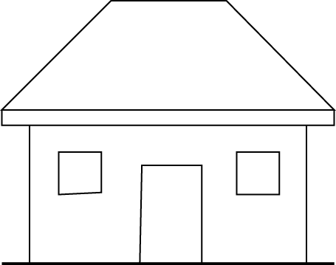
Ventilators

27. In which way is a pool of water near a home likely to be a source of malaria to the people in that home?
Provide breeding places for mosquitoes
28. How does a bat differ from all the other mammals?
A bat flies
29. Apart from contracting sexually transmitted diseases, why would you advise a girl has started menstruating to abstain from sex?
They may get pregnancy and drop out of school
30. Draw an example of a foot of a swimming bird in the space provided below.
web

31 Why is a splint necessary when giving First Aid to someone with broken limb?
To minimize movement of broken bones
To reduce further injury
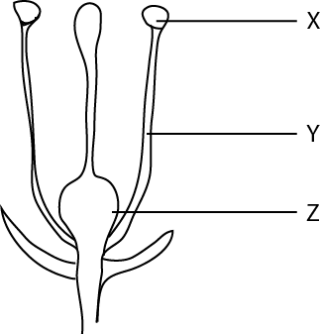
The diagram below is of a flower. Use t to answer question 32 to 34.

32. Name the part labeled X anther head
33. What is the use of the part labelled Y to the flower?
To hold the anther head
34. What does the part labeled Z become after fertilization?
Fruit
35. Give any one reason why it is important to weed crops.
Remove competition of weeds with crop
To increase penetration of light
To reduce spread of diseases
36. If a person enters a room and begin smoking, how does that habit affect the health of the people in the room?
They become passive smoker and can suffer from lung disease
37. In which part of the human body are the red blood cells made?
Red bone marrow
38. What process will you use to recover salt which has dissolved in water?
Evaporation
39. Which instrument is used to measure the temperature of human body?
Thermometer
40. What first aid would you give to a child who has drunk paraffin?
Give a lot of milk to dilute paraffin
SECTION B
41. The diagram bellow show two types of simple machines labelled a and b
Use it to answer the questions that follow.
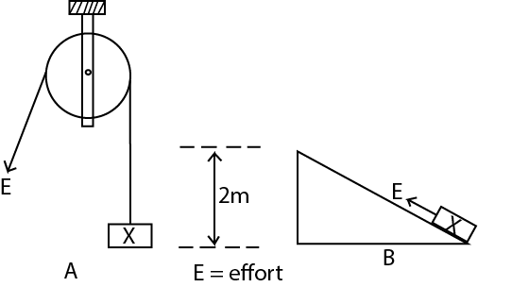
(a) Name each of the machines shown in the diagram
(i) A: single fixed pulley
(ii) B: inclined plane
(b) Which of the two machines would you choose to use to lift the load X to a height of two metres?
Pulley
(c) Give a reason for your choice of machine in (b) above.
Uses less effort
42. The diagram below shows as onions
Use it to answer the questions that follow
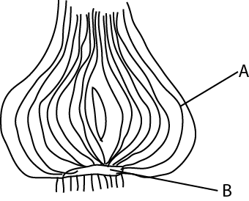

- Name the part labelled B Stem

(b) What is the function of the part labelled A?
Stores food
Protect the bud
(c) what types of root system does this plant have?
Adventitious root (adventitious root are those that develop from stem)
(d) How is this plant propagated?
By planting the bulb
By seeds
43. The two lists A and A below, show the diagram and the animals they affect .match the items in list a with those in list B correctly by completing the table below.
List A List B
New castle cattle
African swine fever Dogs
Rabies pigs
Rinderpest fowls
(a)New castle  (b)African swine fever  (c )Rabies  (d)Rinderpest | fowls  pigs  dogs  cow
44. (a) Why should water not be used to put out a fire caused by petrol?
Petrol floats on water and continues to burn
Water contain oxygen that supports burning
(b) Suggest any two ways in which such a fire can be put out.
Using fire extinguisher
Using sand or soil
Use blanket
(c) How is a burn different from a scald?
A burn is caused by naked fire or hot object while a scald is caused by hot water
45. How does each of the following animals protect itself against its enemies?
(a)Tortoise by hiding in its shell
(b)Wasp by stinging its enemy
(c) Millipede it coils its body
(d)Chameleon: by changing color to match with environment
46.Give any four main causes of motor accidents in Uganda
(a) driving when drunk
(b) over speeding
(c) ignoring road signs
(d) animal crossing
(e) bad roads
47. (a) What advice would you give to a person wishing to construct a pit latrine at his home?
(i) it should be 10m from the main house
(ii) should not be near a water source
(iii) should be built with easily washable material
(iv) should have a vent pipe
(b) Give any one characteristic of a Ventilated Improved Pit Latrine
(i) has a vent pipe
(ii) it remains open
(c) Give any one reason why people should use latrines /toilets properly.
To prevent spread of diseases like dysentery and cholera
48. Mention any one reason why copper wires are commonly used to distribute electricity from one point to another.
Copper is a good conductor of electricity
(b) Why do people who work on electric wires wear rubber gloves?
To prevent being electrocuted
(c) Give any one use of each of the following:
(i) a switch breaks the circuit and complete the circuit
(ii) a fuse breaks the circuit when there is short circuit
49. (a) Which bone joint the pelvis and the tibia?
Femur
(b) Apart from movement, give any other two functions of the human skeleton.
(i) protects delicate organs
(ii) provide shape for smooth movement
(iii) store mineral
(iv) manufacture blood cells
(c) What is the function of tendons in a human body?
A tendon joins a muscle to a bone
50. (a) In which way does the cutting of tress (deforestation) cause soil erosion?
This leaves land bear and exposed to agents of soil erosion such as running water, wing and animals
(b)Suggest any three methods of farming which can prevent soil erosion.
(i) terracing
(ii) mulching
(iii) strip cropping
51.(a) Give any one danger to a person who gets used to taking drug of dependency.
(i) leads to brain damage
(ii) leads to self-neglect
(iii) leads to neglect of jobs
(iv) leads to death
(b) Suggest any three reasons why it is not advisable to take drugs bought from local shops.
- you may take wrong dose
(ii) you may take wrong drug
(iii) may take expired drugs
(iv) may take contaminated drug
52 (a) What do you understand by ‘dual purpose’ cattle?
Dual-purpose cattle are cattle kept for milk and beef
(b) Give any two common local breeds of cattle kept in Uganda
(i) Zebu cattle
(ii) long horned cattle
(c) Suggest any one reason why cattle keepers practice cross-breeding.
To improve on milk production
To improve on beef production
53. The diagram below shows the human arm holding a stone
Use it to answer the question that follow
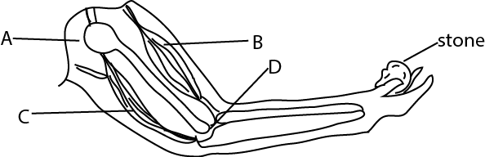
(a) Which muscle acts as the effort in order to lift the stone?
Muscle B
(b) What kind of movement is possible at each of the following joint?
(i) joint A: Move in all direction (ball and socket joint)
(ii) joint D: move in one plane (hinge joint)
(c) Which class of lever is represented by the diagram above?
Third class lever
54. Use one sentence to explain the meaning of each of the following:
(a) reflection of light
Is the bouncing back of light.
(b) conduction of heat
Is a process by which heat move from one part of a solid to another?
(c) Transpiration
This is the loss of water from a plant leaves
(d) condensation
This is a process by which vapour turns to a liquid
55. The table below shows food stuffs prepared in different families
Study it and answer questions that follow
Family A | Family B | Family C | Family D
Matooke  Yams  Meat  beans | Cassava  Beans  Posho  yams | Potatoes  Posho  Cassava  yams | Millets  Fish  Goat milk  Mangoes

(a) Which family will be able to have vitamin C? D

(b) Which family has proteins but lacks fats? B

(c) What food nutrients are lacking in family A?
Vitamin C
(d) Which family has almost a balanced diet?
D
END

